Butterfly Tracking System (BTS)

Use Case Specification Document

UC-4
Update Butterfly Sighting and Tagging
Version No. 1.1

Project Document Revision History
Version Number | Date | Revision Author | Description of Revision
1.0 | 11/19/2015 | Nesrin Mohammed | Initial Release
1.1 | 11/22/2015 | Yue Dai | Modify introduction, use case interaction, swinlane diagrams, main flows and alternate flows

Table of Contents

1. Introduction 4
2. Use Case Information 4
2.1 Actors 4
2.2 Use Case Interaction 4
3. Trigger 5
4. Pre-condition(s) 5
5. Post Condition 5
6. Use Case Swimlane (Activity) Diagram 5
6.1 Update own tagging records: 6
6.2 Update own sighting records 7
6.3 Update own account information 8
7. Main/Basic Flow(s) of Events (Happy Path) 9
7.1 Update own tagging records: 9
7.2 Update own sighting records: 9
7.3 Update own account information 10
8. Alternate/Exception Flow of Events 10
8.1 Re-enter valid data: 10
8.2 Duplicate email address: 10
9. Assumptions/Business Rules including Non-Functional Requirements 11
10. Use Case Specification Review and Signoff 11

Introduction
The tracking or sighting data that collected by reporters should be added to previous information that been collected to maintain updated records of butterfly tracks. Registered users have the ability to update data by modify their own tagging record or sighting record inside the system. The system should have ability to validate entered data. The system prompts the user by prober messages depends on process steps. The functionalities are categorized into either functional or non-functional requirement. The functional ones listed are as follows:
- Registered user updates his/her own tagging report
- Registered user updates his/her own sighting report
- Registered user updates his/her own account

Our system is a web-based project. The user interface is to be function accurately on all platforms, including desktop computers, notebooks, and mobile devices.

Use Case Information

Actors
Actor Name | Role | Description
Registered user | Main | Any user who has an account in BTS and can access to the system
Administrator | Secondary | Registered Users that have full right access to manage the system

Use Case Interaction
This use case has a few predecessors, but it has no successor.
The following Use Cases are the predecessors of Update Butterfly Sighting and Tagging:
- UC-1 Retrieve Butterfly Reports
- UC-2 Session Management
See the appropriate Use Case Specification Document for more information about the use cases above.

Trigger
The triggers for each functionality are described in the following table:

Functionality | Trigger
Registered user update his/her own tagging report | Update button pressed by registered user after inputting the criteria of tagging report (e.g. location, state, tagger ID, tagger ID, etc.).
Registered user update his/her own sighting report | Update button pressed by registered user after inputting the criteria of sighting report (e.g. location, state, tagger ID, sighter ID, etc.).
Registered user update his/her own account | Update button pressed by registered user after inputting the criteria of his/her own account (e.g. email address, password, street, and state, etc.).

Pre-condition(s)
A registered user must be logged in the system to have right access of updating data.

Post Condition
The system will show a new window that will either contain a table or a simple message to the registered user. The following determine the post condition of this use case:
    - Display a table to the registered user containing all the data of the account that has just been updated.
    - Display a table to the registered user containing all the date of the record that has just been updated.
    - Display a notification to show the result of the operation.

Use Case Swimlane (Activity) Diagram
In this section user refers to both Registered Users and Administrators.

Update own tagging records:
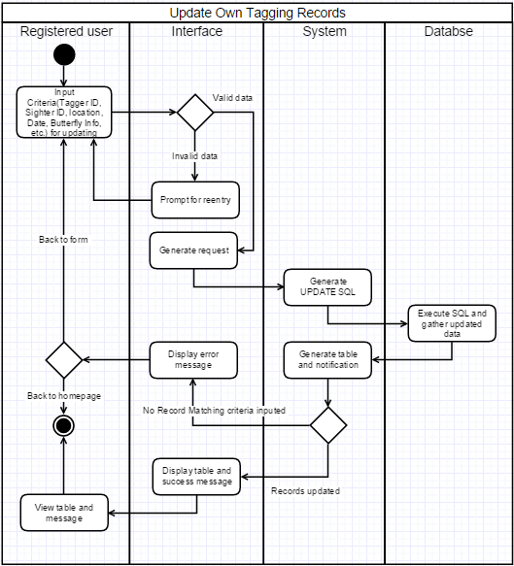
Diagram 6.1 Version 1.1 11/22/2015

Update own sighting records
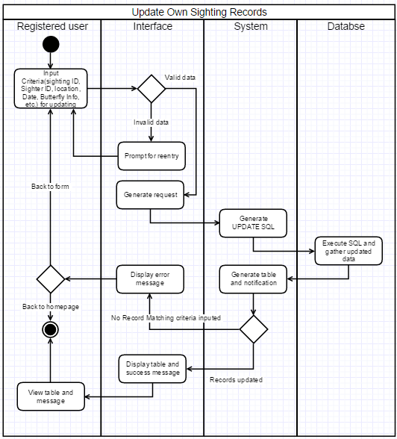
Diagram 6.2 Version 1.0 11/22/2015

Update own account information
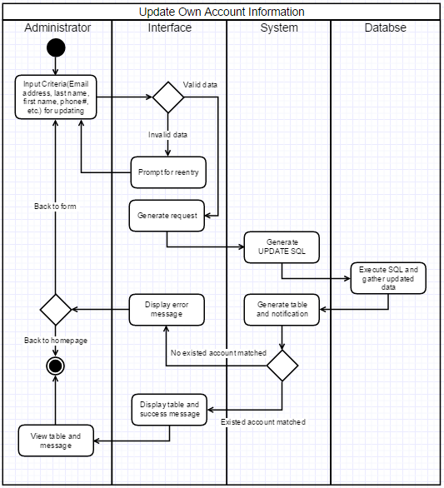
Diagram 6.3 Version 1.0 11/22/2015

Main/Basic Flow(s) of Events (Happy Path)
In this section user refers to both Registered Users and Administrators.

Update own tagging records:
Refer to Diagram 6.1 for a visual of this flow.
- The user will enter criteria of tagging report (e.g. butterfly ID, location, date).
- The interface validates the entry.
  - Invalid data: Require the user to revise enter data.
  - Valid data: The system upload data to database.
- The system will check if the entered criteria does exist or not in the database.
  - Unmatched criteria with display a message through the interface.
  - Updated tagging record will be sent to the interface
- The interface will show the updated tagging record from system and display a success notification

Update own sighting records:
- The user will enter criteria of sighting report (e.g. latitude, longitude, location, date).
- The interface validates the entry.
  - Invalid data: Require the user to revise enter data.
  - Valid data: The system upload data to database.
- The system will check if the entered criteria does exist or not in the database.
  - Unmatched criteria with display a message through the interface.
  - Updated tagging record will be sent to the interface
- The interface will show the updated sighting record from system and display a success notification

Update own account information
- The user will enter criteria of his/her own account (e.g. email address, password, last name, first name, etc.).
- The interface validates the entry.
  - Invalid data: Require the user to revise enter data.
  - Valid data: The system upload data to database.
- The system will send the entered criteria to the database and check if the inputted email address is distinct or not.
  - Duplicate email address will be displayed through the interface and user will be asked to input a new email address again.
  - Distinct email address will be updated and will be sent to the interface
- The interface will show the updated account information from system and display a success notification

Alternate/Exception Flow of Events
In this section user refers to both Registered Users and Administrators.

Re-enter valid data:
    - The user will input criteria for updating tagging/sighting record or account information
    - The interface will check the validation of inputted data
    - The interface will show error message and ask user to enter the criteria again

Duplicate email address:
    - The user will input criteria for updating account information
    - The interface will check the validation of inputted data
    - The system will generate UPDATE SQL and send it to the database
    - The database will send error message to the interface through the system
    - The interface will show the error message and ask user to enter a new email address

Assumptions/Business Rules including Non-Functional Requirements
The browsers that are used to access to the system are modern and capable of properly displaying the reports generated by the system.

Use Case Specification Review and Signoff
Review and Signoff of the Use Case Specification
Name | Project Team Role | Signature | Date
Issam Jassim | Team Leader | Ikj | 11/24/2015
Yue Dai | Front-end Developer | Yd | 11/24/2015
Xiuyan Xin | Front-end Developer | xx | 11/24/2015
Nesrin Mohammed | Database Manager | nm | 11/24/2015

